1) Write a program to print the following pattern

Sample Input:

Enter the number to be printed: 1

Max Number of time printed: 3

1

11

111

11

1

PROGRAM :-

import java.util.*;

public class diamand {

    public static void main(String[] args) {

        int i,j,n;

        String h;

        Scanner v = new Scanner(System.in);

        System.out.println("enter the symbol : ");

        h = v.nextLine();

        System.out.println("enter the numbers :");

        n = v.nextInt();

        for(i=1;i<=n;i++)

        {

            for(j=1;j<=i;j++)

            {

                System.out.print(h+" ");

            }

            System.out.println();

        }

        for(i=n-1;i>=1;i--)

        {

            for(j=1;j<=i;j++)

            {

                System.out.print(h+" ");

            }

            System.out.println();

        }

    }

}

OUT PUT :-

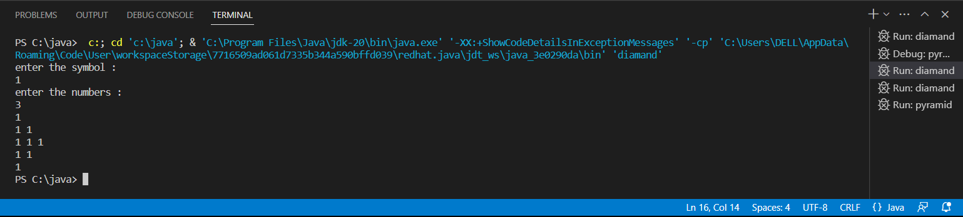

2) Write a program to print the following pattern

Sample Input:

Enter the Character to be printed: %

Max Number of time printed: 3

%

% %

% % %

PROGRAM :-

import java.util.*;

public class pyramid {

    public static void main(String[] args) {

        int i,j,n;

        String h;

        Scanner v = new Scanner(System.in);

        System.out.println("enter the symbol : ");

        h = v.nextLine();

        System.out.println("enter the numbers :");

        n = v.nextInt();

        for(i=0;i<n;i++)

        {

            for(j=0;j<=i;j++)

            {

                System.out.print(h+" ");

            }

            System.out.println();

        }

    }

}

OUT PUT :-

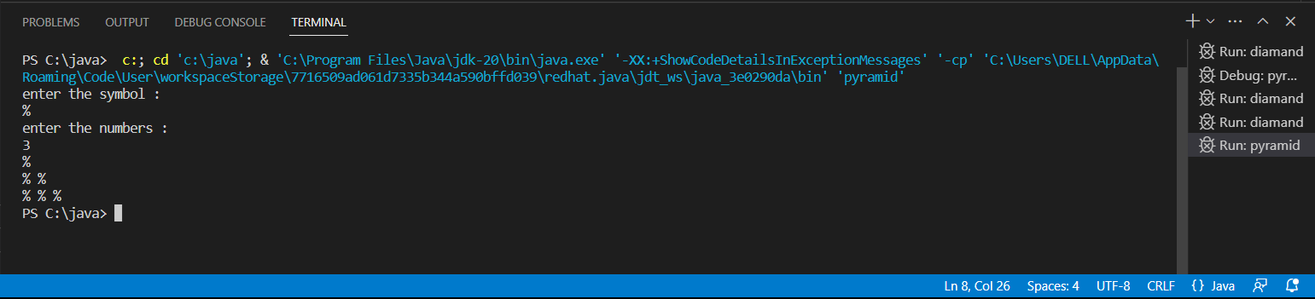

3) Write a program to print Right Triangle Star Pattern

Sample Input:: n = 5

Output:

*

* *

* * *

* * * *

* * * * *

PROGRAM :-

import java.util.*;

public class rightangle {

    public static void main(String[] args) {

        int i,j,n;

        Scanner v = new Scanner(System.in);

        System.out.println("enter the numbers :");

        n = v.nextInt();

        for(i=0;i<n;i++)

        {

            for(j=0;j<=i;j++)

            {

                System.out.print("* ");

            }

            System.out.println();

        }

    }

}

OUTPUT :-

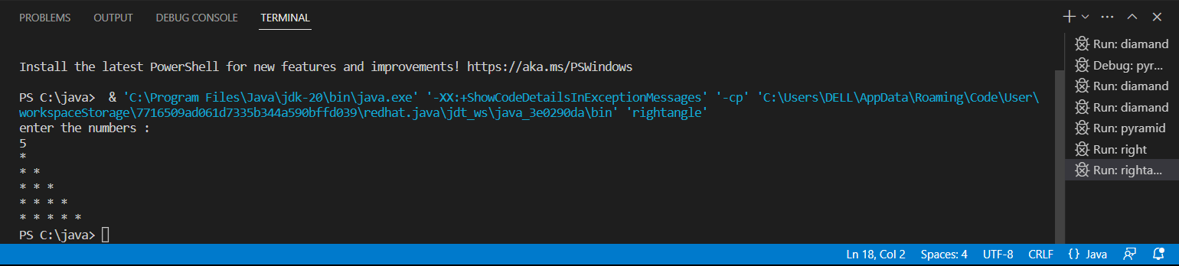

4) Write a program to print the below pattern?

1

1 1

1 2 1

1 3 3 1

1 4 6 4 1

PROGRAM :-

import java.util.*;

public class pascal {

   public static void main(String[] args)

   {

      int row, i, j, space, num;

      Scanner sc=new Scanner(System.in);

      System.out.print("Enter no. of rows: ");

    if(!sc.hasNextInt())

    {

        System.out.println("Invalid Enter only integers");

        return;

    }

      row=sc.nextInt();

      for(i=0; i<row; i++)

      {

         for(space=row; space>i; space--)

         {

            System.out.print(" ");

         }

         num=1;

         for(j=0; j<=i; j++)

         {

            System.out.print(num+" ");

            num = num*(i-j)/(j+1);

         }

         System.out.println();

      }

   }

}

OUTPUT :-

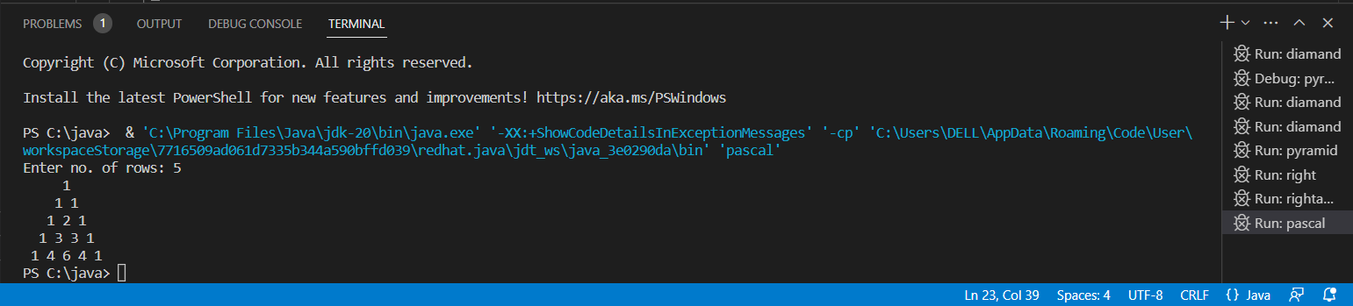

5) Write a program to print the below pattern

1

2  2

3  3  3

4  4   4   4

PROGRAM :-

import java.util.*;

public class numberpattern123 {

    public static void main(String[] args) {

        int i,j,n;

        Scanner v = new Scanner(System.in);

        System.out.println("enter the number: ");

        n = v.nextInt();

        for (i=1;i<=n;i++)

        {

            for (j=0;j<i;j++)

            {

                System.out.print(i+ " ");

            }

            System.out.println();

        }

    }

}

OUTPUT :-

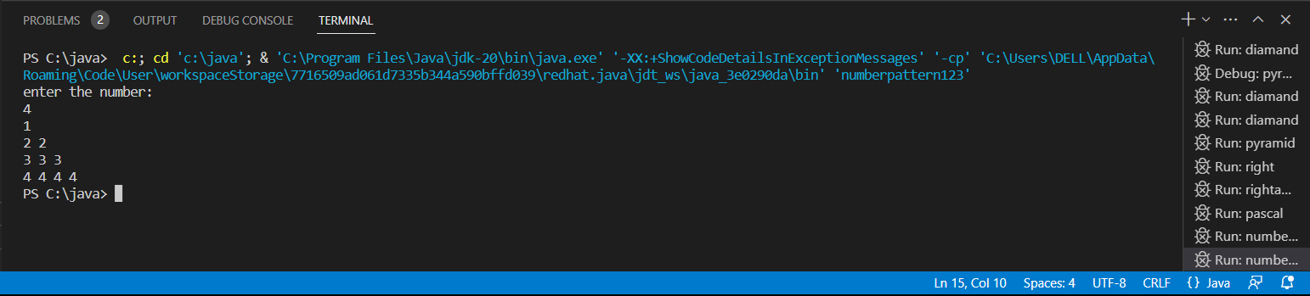

6) Write a program to print the below pattern

1

2 2

3  3  3

4  4   4   4

3  3  3

2  2

1

PROGRAM :-

import java.util.*;

public class numberpattern {

    public static void main(String[] args) {

        int i,j,n;

        String h;

        Scanner v = new Scanner(System.in);

        System.out.println("enter the numbers :");

        n = v.nextInt();

        for(i=1;i<=n;i++)

        {

            for(j=1;j<=i;j++)

            {

                System.out.print(i+" ");

            }

            System.out.println();

        }

        for(i=n-1;i>=1;i--)

        {

            for(j=1;j<=i;j++)

            {

                System.out.print(i+" ");

            }

            System.out.println();

        }

    }

}

OUT PUT :-

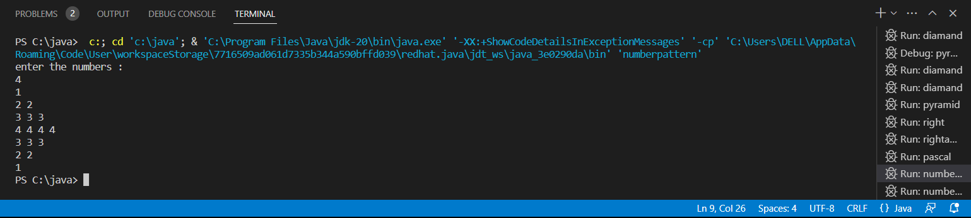

7) Write a program to print hollow Square Dollar pattern?

PROGRAM :-

import java.util.*;

public class hallowsquare {

public static void main(String[]args)

{

int m,n,i,j;

String s;

Scanner v = new Scanner (System.in);

System.out.println("enter the symbol :");

s = v.nextLine();

System.out.println("enter the number of rows :");

m = v.nextInt();

System.out.println("enter the number of column :");

n = v.nextInt();

for (i=1;i<m+1;i++)

{

for (j=1;j<n+1;j++)

{

if(i == 1 || i == m || j == 1 || j == n)

{

System.out.print(s+" ");

}

else

{

System.out.print("  ");

}

}

System.out.println();

}

}

}

OUT PUT :-

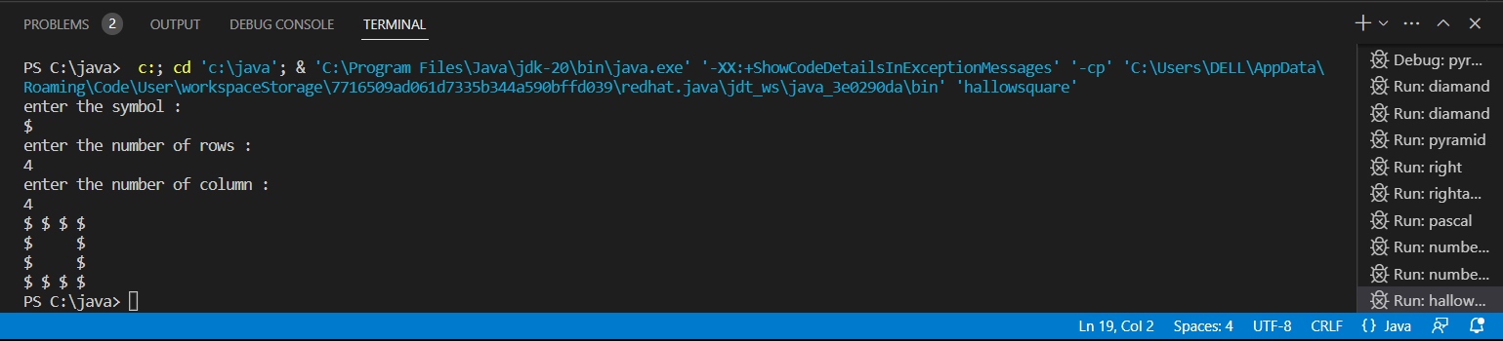

8) Write a program to print hollow square symbol pattern?

PROGRAM :-

import java.util.*;

public class hallowsquare {

public static void main(String[]args)

{

int m,n,i,j;

String s;

Scanner v = new Scanner (System.in);

System.out.println("enter the symbol :");

s = v.nextLine();

System.out.println("enter the number of rows :");

m = v.nextInt();

System.out.println("enter the number of column :");

n = v.nextInt();

for (i=1;i<m+1;i++)

{

for (j=1;j<n+1;j++)

{

if(i == 1 || i == m || j == 1 || j == n)

{

System.out.print(s+" ");

}

else

{

System.out.print("  ");

}

}

System.out.println();

}

}

}

OUTPUT :-

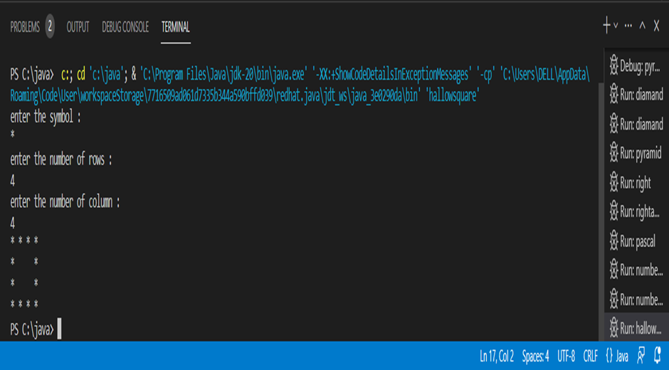

9) Given an integer x, return true if x is a Palindrome , and false otherwise.

Example 1:

Input: x = 121

Output: true

Explanation: 121 reads as 121 from left to right and from right to left.

PROGRAM :-

import java.util.*;

public class palindrome

{

    public static void main(String[] args) {

        int num,r,reversed=0;

        Scanner v = new Scanner(System.in);

        System.out.println("enter the number :");

        num = v.nextInt();

        int original = num;

        while(num!=0)

        {

            r = num%10;

            reversed = reversed*10+r;

            num/=10;

        }

        if(original==reversed)

        {

            System.out.println("It is  Palindrome Number");

        }

        else

        {

            System.out.println("It is not Palindrome Number");

        }

    }

}

OUTPUT :- 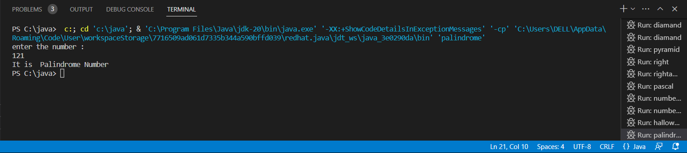

10) Write a program to print rectangle symbol pattern. Get the symbol as input from user

PROGRAM :-

import java.util.*;

public class fullrectangle {

public static void main(String[]args)

{

int m,n,i,j;

String s;

Scanner v = new Scanner (System.in);

System.out.println("enter the symbol :");

s = v.nextLine();

System.out.println("enter the number of rows :");

m = v.nextInt();

System.out.println("enter the number of column :");

n = v.nextInt();

for (i=1;i<m+1;i++)

{

for (j=1;j<n+1;j++)

{

System.out.print(s+" ");

}

System.out.println();

}

}

}

OUTPUT :-

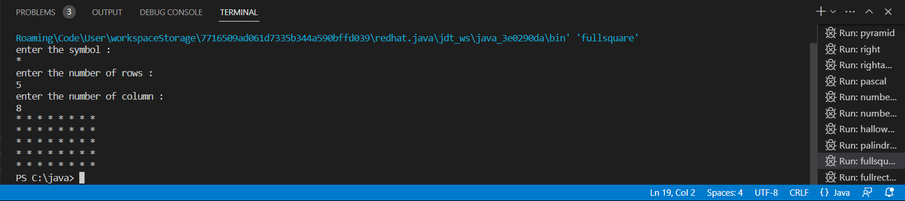

11) Write a program for matrix addition?

Sample Input:

Mat1 = 1  2

5  3

Mat2 = 2   3

              4   1

Sample Output:

Mat Sum = 3    5

9 4

PROGRAM :-

import java.util.Scanner;

public class matrixaddition {

    public static void main(String[] args) {

      int i,j;

       Scanner s = new Scanner(System.in);

        System.out.println("Enter no of rows:");

        i = s.nextInt();

        System.out.println("Enter no of columns:");

        j = s.nextInt();

        int a[][] = new int[i][j];

        int b[][] = new int[i][j];

        int c[][] = new int[i][j];

       System.out.println("Mat1 =");

       for(i=0;i<2;i++)

       {

           for(j=0;j<2;j++)

           {

                a[i][j] = s.nextInt();

           }

       }

       System.out.println("Mat2 =");

       for(i=0;i<2;i++)

       {

           for(j=0;j<2;j++)

           {

               b[i][j] = s.nextInt();

           }

         }

       System.out.println("Mat Sum =");

       for(i=0;i<2;i++)

       {

           for(j=0;j<2;j++)

           {

               c[i][j] = a[i][j]+b[i][j];

               System.out.print(c[i][j]+"  ");

           }

           System.out.println();

       }

    }

}

OUTPUT :-

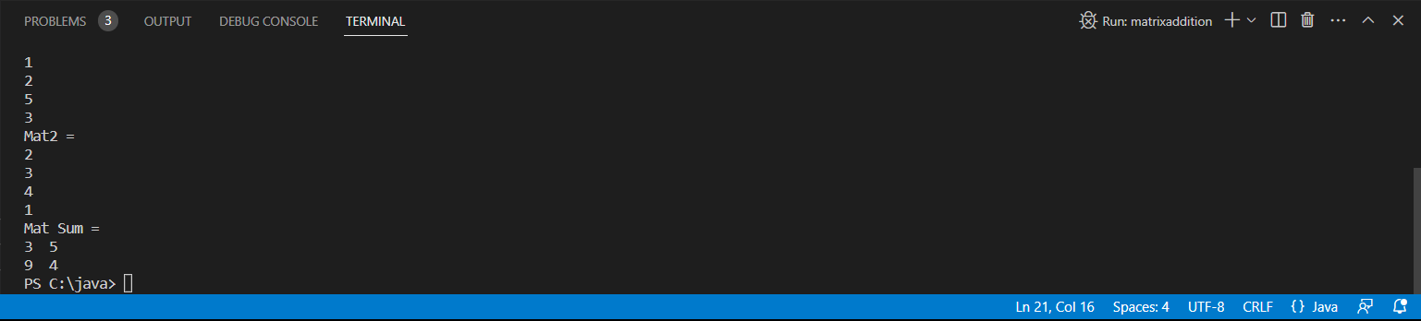

12) Write a program to print inverted pyramid pattern.

Input: no of rows: 3

Output

    *****

     ***

       *

PROGRAM :-

import java.util.*;

public class invertedtriangle

 {

        public static void main(String[] args)

         {

            int rows;

            Scanner v = new Scanner(System.in);

            System.out.println("enter the number :");

            rows = v.nextInt();

            for (int i = rows; i >= 1; i--) {

                for (int j = 1; j <= rows-i; j++)

                {

                    System.out.print("  ");

                }

                for (int k = 1; k <= 2*i-1; k++)

                {

                    System.out.print("* ");

                }

                System.out.println();

            }

        }

    }

OUTPUT :-

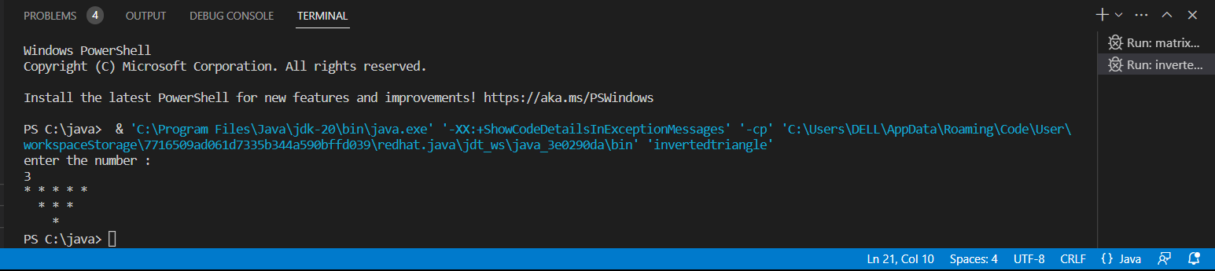

13) Write a program to print the below pattern

1

2  2

3  3  3

4  4   4   4

PROGRAM :-

import java.util.*;

public class numpattern1 {

public static void main(String[] args)

{

int i, j, rows;

Scanner sc = new Scanner(System.in);

System.out.print("Enter the number of rows you want to print: ");

rows = sc.nextInt();

for (i = 1; i <= rows; i++)

{

for (j = 1; j <= i; j++)

{

System.out.print(i+" ");

}

System.out.println();

}

}

}

OUTPUT :-

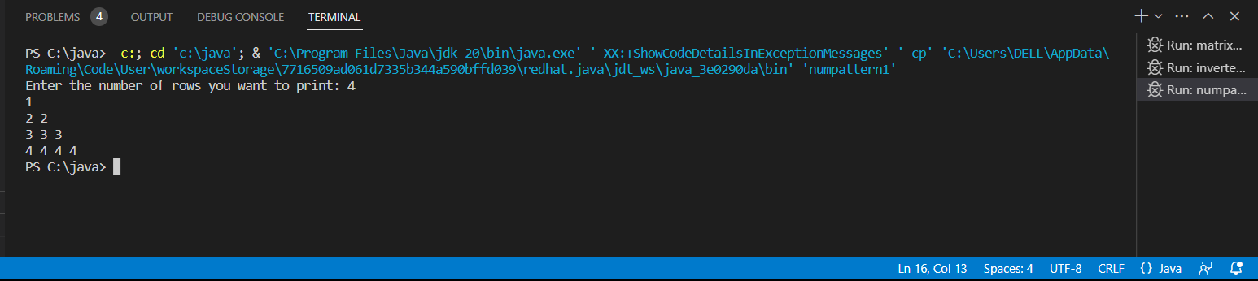

14) Write a program to print the below pattern

1

2 2

3  3  3

4  4   4   4

3  3  3

2  2

1

PROGRAM :-

public class numpattern2 {

public static void main(String[] args)

{

int i,j;

for(i=1;i<5;i++)

{

for(j=1;j<=i;j++)

{

System.out.print(i+" ");

}

System.out.println();

}

for(i=3;i>0;i--)

{

for(j=i;j>0;j--)

{

System.out.print(i+" ");

}

System.out.println();

}

}

}

OUTPUT :-

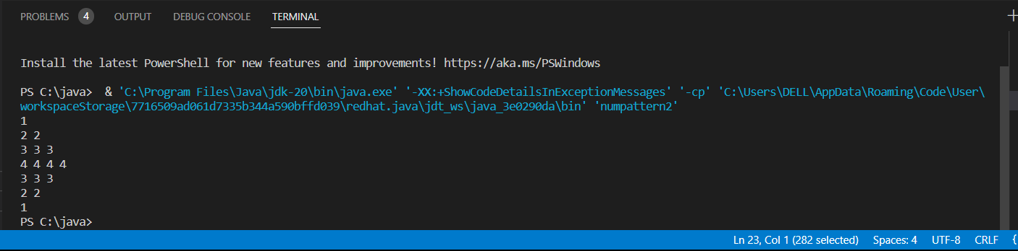

15) Write a program to print the below pattern

1

4     9

16   25    36

49   64    81    100

PROGRAM :-

import java.util.*;

public class squarepattern {

    public static void main(String[] args){

        Scanner sc=new Scanner(System.in);

        System.out.println("enter the number :");

        int n=sc.nextInt();

        int a,b,k=1;

        for(a=1;a<n;a++){

            for(b=1;b<=a;b++){

                System.out.print((int)Math.pow((k++),2)+" ");

            }

            System.out.println();

           }

        }

    }

OUTPUT :-

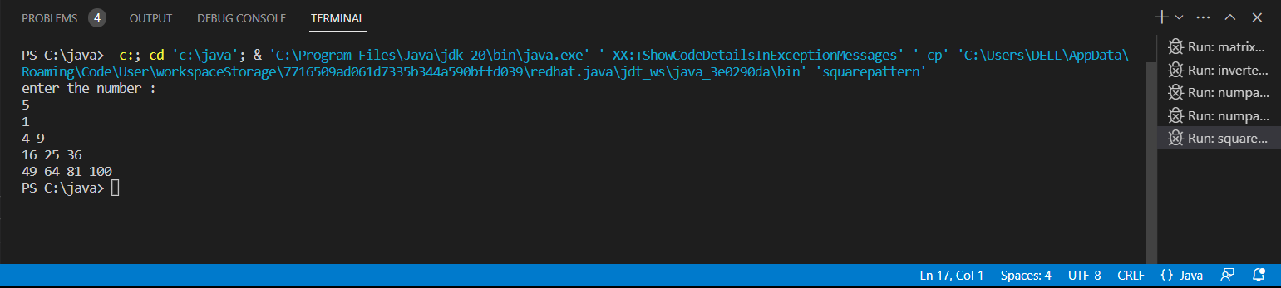

16) Write a program for matrix multiplication?

Sample Input:

Mat1 = 1  2

5  3

Mat2 = 2   3

              4   1

Sample Output:

Mat Sum = 10    5

                    22    18

PROGRAM :-

public class matrixmulti {

public static void main(String args[])

{

int a[][]={{1,1,1},{2,2,2},{3,3,3}};

int b[][]={{1,1,1},{2,2,2},{3,3,3}};

int c[][]=new int[3][3];

for(int i=0;i<3;i++)

{

for(int j=0;j<3;j++)

{

c[i][j]=0;

for(int k=0;k<3;k++)

{

c[i][j]+=a[i][k]*b[k][j];

}

System.out.print(c[i][j]+" ");

}

System.out.println();

}

}

}

OUTPUT :-

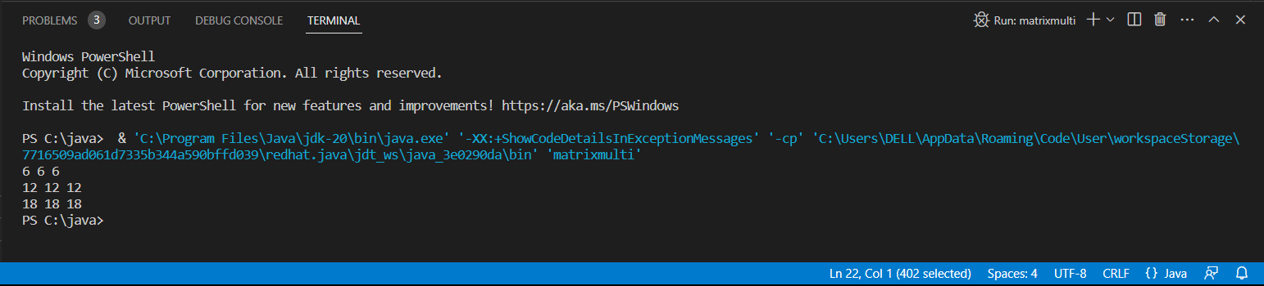

17) Given a non-negative integer x, return the square root of x rounded down to the

nearest integer. The returned integer should be non-negative as well.

You must not use any built-in exponent function or operator.

For example, do not use pow(x, 0.5) in c++ or x ** 0.5 in python.

Example 1:

Input: x = 4

Output: 2

Explanation: The square root of 4 is 2, so we return 2.

Example 2:

Input: x = 8

Output: 2

Explanation: The square root of 8 is 2.82842..., and since we round it down to the nearest

integer, 2 is returned.

class Solution {

    int mySqrt(int x) {

    }

}

PROGRAM :-

public class square {

        public int mySqrt(int x) {

           if (x < 2) return x;

            int end = x / 2;

            int start = 1;

            while (start <= end) {

                int mid = (start + end) / 2;

                if ((long)mid*mid > x) {

                    end = mid - 1;

                } else {

                    start = mid + 1;

                }

            }

            return end;

        }

    }

18) Find the Mean, Median, Mode of the array of numbers?

Sample Input;:

Array of elements = {16, 18, 27, 16, 23, 21, 19}

Sample Output:

Mean = 20

Median = 19

Mode = 16

PROGRAM :-

import java.io.*;

import java.lang.*;

public class meanmedian {

public static void main(String[] args)

{

int[] invalue = new int[]{2,4,5,2,6};

int num_value=5;

double tot=0;

double mean=0;

for(int i=0; i<num_value; i++)

{

tot = tot+invalue[i];

}

mean = tot/num_value;

System.out.println("The mean value is: "+mean);

double median = 0;

double mid=0;

if(num_value%2 == 0)

{

int temp=(num_value/2)-1;

for(int i=0;i<num_value;i++)

{

if(temp==i || (temp+1)==i)

{

mid=mid+invalue[i];

}

}

mid=mid/2;

System.out.println("Median value is: "+mid);

}

else

{

int temp=(num_value/2);

for(int i=0;i<num_value;i++)

{

if(temp==i)

{

mid=invalue[i];

System.out.println("Median value: "+mid);

}

}

}

int i,j,z, tmp, maxCount, modeValue;

int[] tally=new int[num_value];

for(i=0;i<num_value;i++)

{

for(j=0;j<num_value-i;j++)

{

if(j+1!=num_value)

{

if(invalue[j]>invalue[j+1])

{

tmp=invalue[j];

invalue[j]=invalue[j+1];

invalue[j+1]=tmp;

}

}

}

}

for (i = 0; i < num_value; i++)

{

for(z=i+1;z<num_value;z++)

{

if(invalue[i]==invalue[z])

{

tally[i]++;

}

}

}

maxCount = 0;

modeValue = 0;

for (i = 0; i <num_value; i++)

{

if (tally[i] > maxCount)

{

maxCount = tally[i];

modeValue = invalue[i];

}

}

System.out.println("Mode value is :"+modeValue);

}

}

OUTPUT :-

